RESUME
Daud Mohsin

Personal Detail
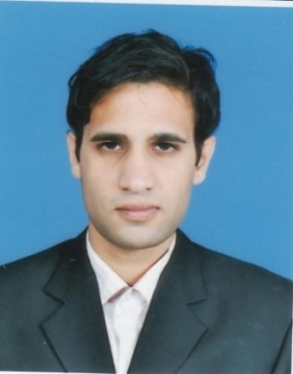
Daud Mohsin

House no 5, block no 34 Sargodha
Telephone 92-0483719911
Mobile 92-03163923934
Email daudmohsin64@yahoo.com
Skype id daudmohsin64

Material Status Single
Date of Birth 17/3/1986
Nationality Pakistani
NIC 38403-7492360-1

Objective
Seeking challenging position in any organization with a professionally enriched environment of dynamic organization and to grow in it by contributing regularly to organization's objective through hard work.
Academic Qualifications
Master of Social Work University of Sargodha 2008-2010
Bachelor of Arts University of Sargodha 2005-2007
Faculty of Arts Sargodha Board 2003-2005
Matriculation Sargodha Board 2000-2002
Language
Proficient in written and spoken English and Urdu
Computer Skills
- Windows 98/2000/XP
- MS Office ( world . excel , power point )
- Internet Surfing
Experience
- Human resource manager at Shahid traders
January 1st 2017 to present
- Teaching Experience
Ahamd Model primary school
December 1st, 2010 to February 15, 2012
- Internship Experience
Internship at Punjab Rural Support Program
October 1, 2009 to June 30, 2010
- Field work in rural community development and urban community development projects
- Research Work
Socio economic factors promoting drug addiction in Pakistan, a Case study of Sargodha city.
Skills Related to Social Work and Human Resource Development
- Case Work Experience
- Research Work Experience
- Community development experience
- Human Resource Development
- Rural development and local Government
- Program administration and policy development Fund raising and donor relation
- Life skills counseling
Reference
Furnished upon request.

